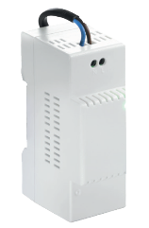

**POWER SUPPLY UNIT**

**

**ACCESSSORY**



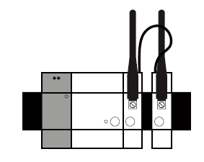

The Somfy DIN Rail Power Supply Module is a required component of the Somfy DIN Rail

Solution.

It is used to power the solution (Central Unit module, compatible Radio Units,…).

CONTENT

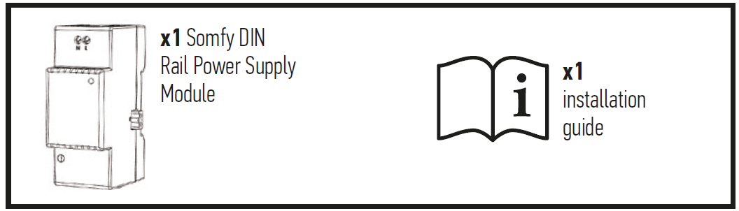

PRODUCT DESCRIPTION

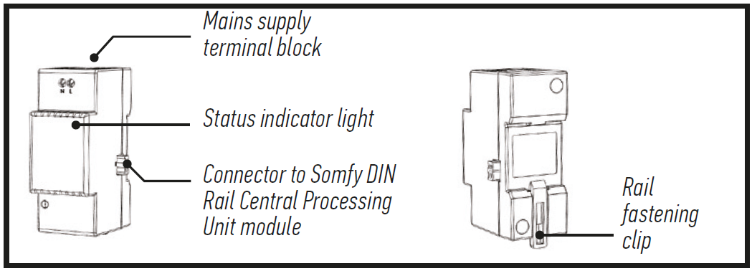

IMPORTANT

**Equipment connected to 230 V power supply.**

• The module must be installed and removed with the power supply switched off.

• We strongly recommend that you add a dedicated circuit breaker module (2 A) to manage

the Somfy DIN Rail solution (upstream of this power supply module).

**Prerequisites**

• Enclosure equipped with a TS-35/7.5 or TS-35/15 DIN Rail.

• The other Somfy DIN Rail modules required: Central Processing Unit module and at least one Radio Unit (maximum of four).

• Installation on a concrete surface or any other non-flammable surface.

• Installation must be carried out by a professional.

TECHNICAL SPECIFICATIONS

|  |  |
| --- | --- |
| **Input power supply** | 100 – 240 V ~ 50 / 60 Hz |
| **Power consumption during normal operation** | 0.26 A |
| **Output power supply** | 5 V continuous 1.8 A |
| **Appliance class** | Class II |
| **Impact rating resistance** | IK07 |
| **Operating temperature** | -10°C to +40°C |
| **Maximum operating altitude** | 2 000 m |
| **Pollution category** | Category 2 |
| **Operating humidity** | 5 % to 90 % |
| **Dimensions (l x w x h)** | 90 x 36 x 58 mm |
| **Plastic casing** | PC V0 |





