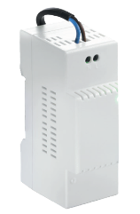

**CENTRAL UNIT**

**

**ACCESSSORY**



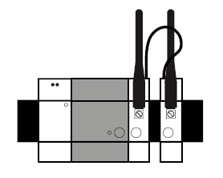

The Somfy DIN Rail Central Unit module is a required component of the Somfy DIN Rail

Solution.

It is the heart of the system and is used to connect other compatible modules (radio, etc.).

CONTENT

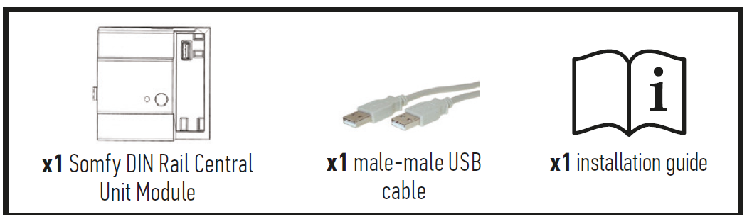

PRODUCT DESCRIPTION

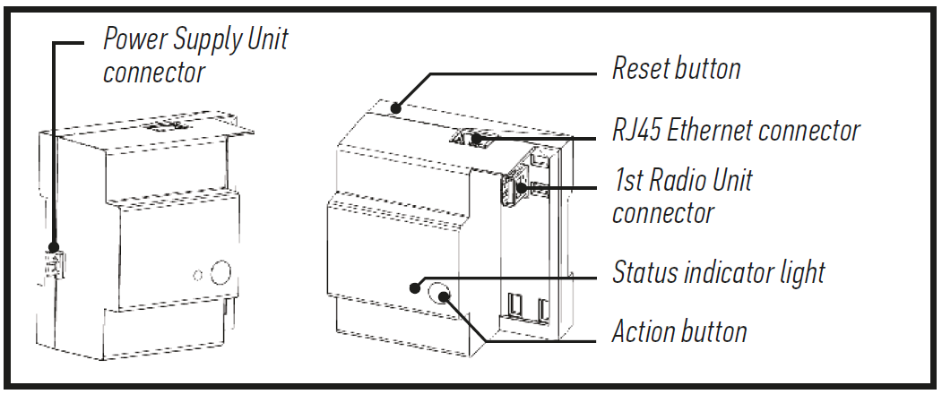

IMPORTANT

**Equipment connected to 230 V power supply.**

The module must be installed and removed with the power supply switched off.

• Do not use a Power over Ethernet (POE) cable.

• Do not connect any load to the available USB port.

**Prerequisites**

Enclosure equipped with a TS-35/7.5 or TS-35/15 DIN Rail.

• The other Somfy DIN Rail modules required: power supply module and at least one Radio Unit (maximum of four).

• Installation must be carried out by a professional

TECHNICAL SPECIFICATIONS

|  |  |
| --- | --- |
| **Power consumption during normal operation** | 5 V continuous 500 mA (0.5 A) |
| **Impact resistance rating** | IK07 |
| **Operating temperature** | -10°C to +40°C |
| **Maximum operating altitude** | 2 000 m |
| **Pollution category** | Category 2 |
| **Operating humidity** | 5 % to 90 % |
| **Dimensions *(l x w x h)*** | 89.5 x 90 x 58 mm |
| **Plastic casing** | PC V0 |





