**VISUEL**

**TBC**

Compatible with Somfy DIN-Rail solutions including the below protocols:



**+** *other compatible protocols using same frequencies to be used later*

**EXTERNAL ANTENNA - 2.4 GHz**

**

**ACCESSSORY**





The External antenna is an accessory of the Somfy DIN Rail solution (Connected Home

box for electrical panel).

It could be used in case of a metal enclosure or cabinet with metal door, that might cause the Radio Module not to operate correctly (radio interferences).

The initial antenna then is to be replaced by an external one.

(1 external antenna per radio module)

CONTENT

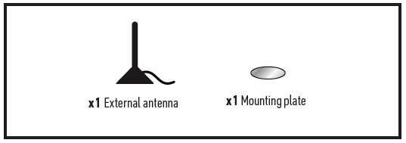

PRODUCT DESCRIPTION

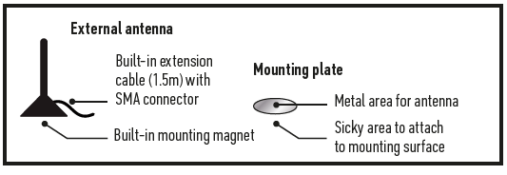

IMPORTANT

**Equipment on which antenna is plugged connected to 230 V power supply.**

**Radio equipment.**

**Prerequisites**

• The other Somfy DIN Rail modules required: power supply module, Central Processing Unit, module, and radio module(s).

• Installation must be carried out by a professional.

TECHNICAL SPECIFICATIONS

|  |  |
| --- | --- |
| **Frequency bands and Maximum power used** | 2.410 GHz -2.490 GHz/erp< 25 mW |
| **Operating temperature** | -40°C to +85°C |
| **Protection rate** | IP 67 |
| **Power handling** | 25W |
| **Connector type** | SMA |
| **Dimensions *(l x w x h)*** | 31 × 31 × 71.5mm |
| **Plastic casing** | ABS |
| **Cable length** | 1.5 m |
| **Mount type** | Magnetic |





